UPDATE: Project Title

*Team Mate1, Team Mate2, Team Mate3*

*{mate1,mate2,mate3}@dsu.edu*

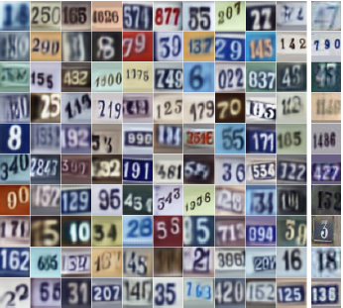

Figure 1. Illustrate your task and/or approach

**1. Task**

Describe the task you are going to solve, e.g. generating natural images like those shown in Fig. 1. Say a few words about what is difficult about the task, e.g. preserving spatial relationships.

**2. Approach**

Outline the approach you plan to take in detail, using diagrams, equations and defining all notation. If you plan to re-use existing libraries or implementations, say which ones, and say what additional code you will write for the project. Note, it is okay to change your approach later in the project, if necessary.

**3. Dataset and Metric**

Say which dataset you will use, how many training and test examples it has, and describe any data pre-processing that will be needed. The dataset must contain sufficient labels if your project needs them, typical machine learning datasets have 10K-1M examples. Some dataset repositories are listed on D2L, and here are a few more:

* [http://deeplearning.net/datasets](http://deeplearning.net/datasets/)
* <https://www.kaggle.com/datasets>
* <http://riemenschneider.hayko.at/vision/dataset>

You should NOT plan on extensive data collection and/or annotation, there is simply no time in such a short project. Define at least one metric you will use to evaluate success, e.g. classification accuracy, defined as … State explicitly how you will measure success, e.g. “we hope to show that our new loss function can improve accuracy on the test set compared to the method in ….”

**4. Preliminary Results**

Talk about the progress you have made so far, specifically, what code implementation has been completed, what preliminary results you obtained on your dataset. Note, if you proposed data collection, the dataset should be ready to use by now, not still being collected/labeled.

**5. Detailed Timeline and Roles**

Each team mate should be assigned some non-trivial coding task.

|  |  |  |
| --- | --- | --- |
| **Task** | **Deadline** | **Lead** |
| Implement X | MM/DD/YY | Team Mate1 |
| Implement Y | MM/DD/YY | Team Mate2 |
| Run tests Z | MM/DD/YY | Team Mate1 |
| ... |  |  |
| Prepare report and presentation | 12/07/17 | all |

NOTE: All progress updates must follow this exact formatting, including fonts, and must not exceed 5 pages